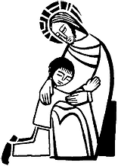
St. Francis Xavier
First Reconciliation and First Eucharist
2021-2022
First Reconciliation
Date/Time | Event/Room
9/19/21 (9:45-10:45) | Parent Meeting/PH
10/17/21 (9:45-10:45) | Workshop 1/PH
11/14/21 (9:45-10:45) | Workshop 2/PH
2/5 (1:30) and 2/13 (3:00) | F.R./ CH
First Communion
1/9/22 (9:45-10:45) | Parent Meeting
1/23/22 (9:45-10:45) | Workshop 1/PH
2/13/22 (9:45-10:45) | Workshop 2/PH
3/13/22 (9:45-10:45) | Workshop 3/PH
4/24/22 (9:45-10:45) | Practice/Church
4/30 and 5/1 (All Masses) | F.C./CH
4/30/22 and 5/1/22 | F.C. Reception/PH

